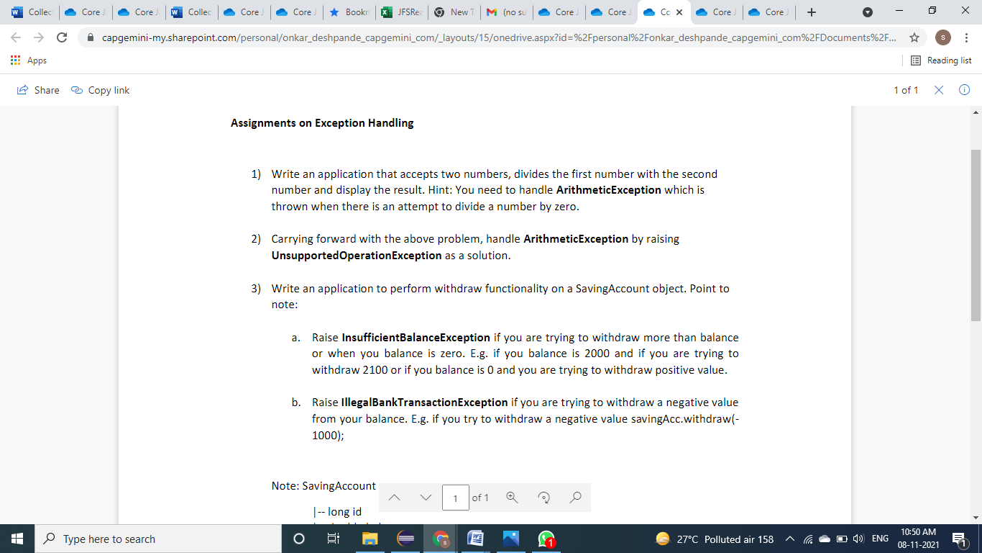

1.

**package** Exceptions;

**import** java.util.*;

**public** **class** ArithmaticException {

**public** **static** **void** main(String[] args)

{

Scanner scan = **new** Scanner(System.***in***);

System.***out***.println("enter a number:");

**int** n1 =scan.nextInt();

System.***out***.println("enter a number:");

**int** n2 =scan.nextInt();

**try**

{

**int** n3 =n1/n2;

System.***out***.println("result:"+n3);

}

**catch**(ArithmeticException except)

{

System.***out***.println("avoid deviding with zero for avoid arithmetic exception");

}

}

}

3.a

**package** Exceptions;

**import** java.util.*;

**public** **class** IlligalBankTransactionExcepyion {

**static** **void** fun() **throws** IllegalAccessException

{

**double** balance = 0, wamount;

Scanner scan = **new** Scanner(System.***in***);

System.***out***.println("Withdraw an amount");

wamount=scan.nextInt();

balance += wamount;

**if** (balance<0)

{

**throw** **new** IllegalAccessException();

}

**else**

System.***out***.println(balance);

}

**public** **static** **void** main(String args[])

{

**try**

{

*fun*();

}

**catch**(IllegalAccessException ex)

{

System.***out***.println("Illegal Bank Transaction Exception occured");

}

}

}

3.b

**package** Exceptions;

**import** java.util.*;

**public** **class** BankAccount {

**static** **void** fun() **throws** inSufficient

{

**double** balance = 0, wamount;

Scanner scan = **new** Scanner(System.***in***);

System.***out***.println("Withdraw an amount");

wamount=scan.nextInt();

balance -= wamount;

**if** (balance<0)

{

**throw** **new** inSufficient();

}

**else**

System.***out***.println(balance);

}

**public** **static** **void** main(String args[])

{

**try**

{

*fun*();

}

**catch**(inSufficient ex)

{

System.***out***.println("Insufficient bank balance Exception occured");

}

}

}